WARKA STRONG APPLE WINE
This product can be known by many Poles and not only, but its appearance doesn't make a good impression.
Here are disadvantages of the product:

- appearance doesn't encourage people to purchase

- nutritional information is not included on the label

- it contains an inappropriate comment at the back of the bottle

- too little information about the product

- Polish product contains the English name, which can be a hassle for people who do not know this language
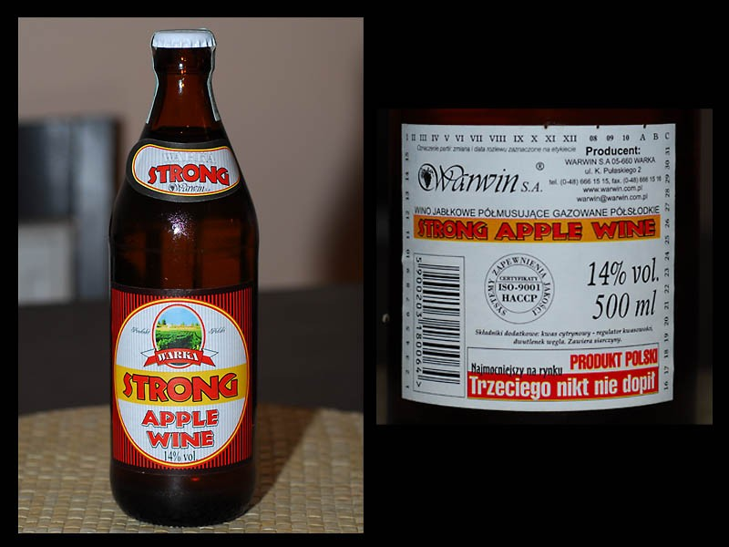

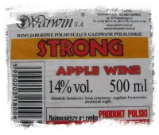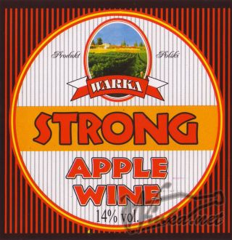
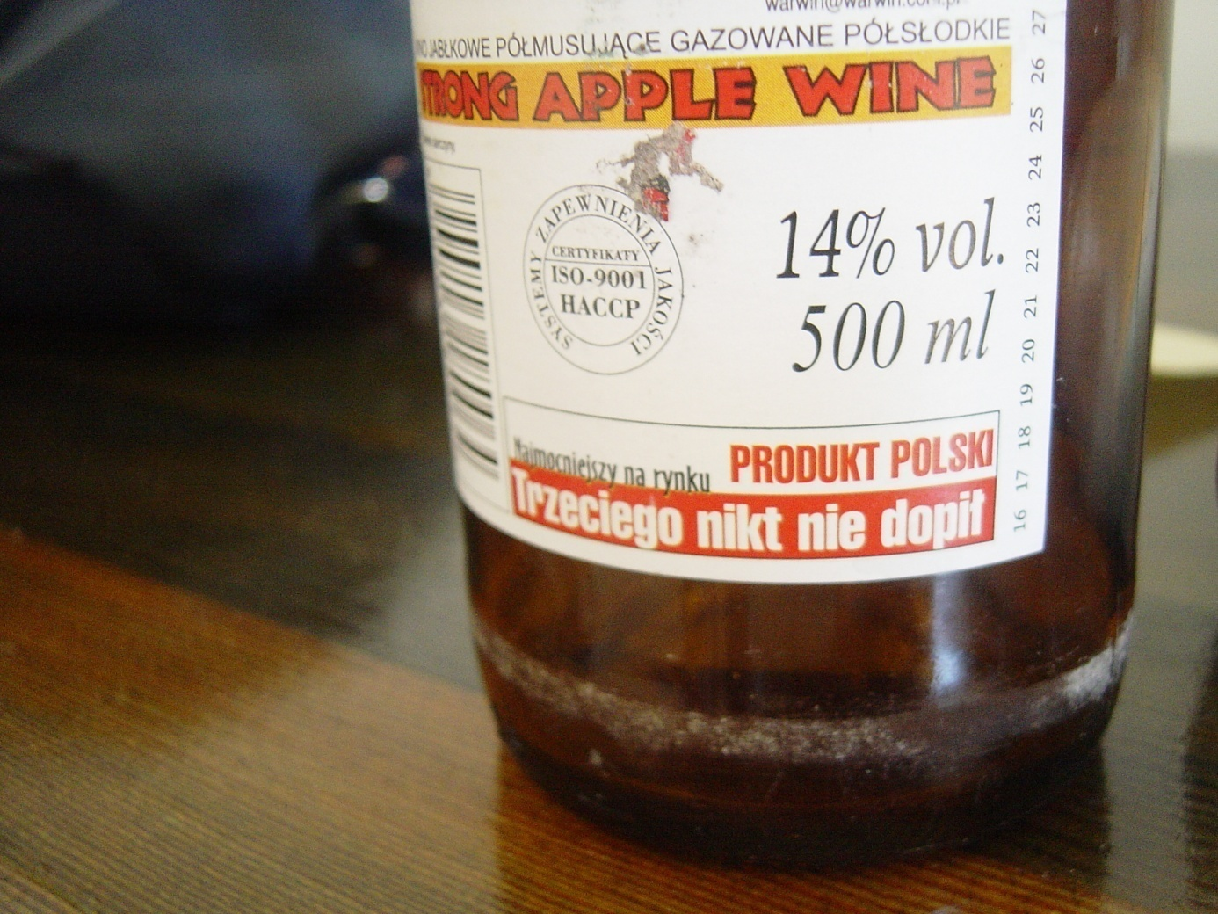

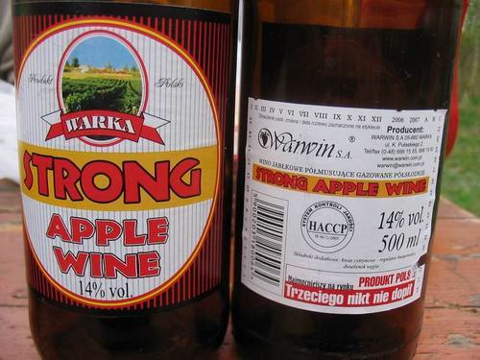

APPLE PRODUCTS
Everyone knows the company “Apple”. They produce electronics for example: smartphones or tablets.
the benefits of these packages:

- white boxes look minimalistic and very elegant, the inscription with the company logo in gold, black, or grey looks great and it is eye-catching

- Apple products are popular and eagerly bought by people because they are good value for money

- at the back of the box there is the whole product information for example: specification of the products, what the package contains, etc.

- inside the box everything is arranged and neatly packed

- recognition of the company is huge and everyone knows that their products are exclusive and of good quality

