Kinga Ciupa
How should the packaging look like?
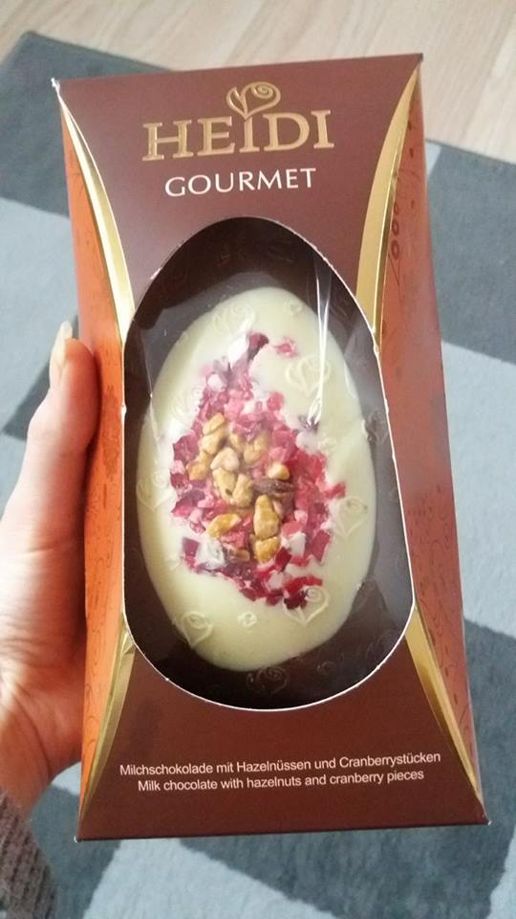
For example, this packaging is good because :
- It is aesthetically done
- In the middle of the box, in a prominent position there is the name of the company
- Consumer can see what is inside
- Chocolate has an unusual shape (egg-shaped), which encourages customers to buy this product as a gift for Easter.
- At the back of the packaging there is a composition of this chocolate egg and additional information about it (manufacturer, expiry date, where it should be stored, nutrition). All this is written in several languages so that the company could gain more customers.
- The packaging is easy to open and close tightly.

How shouldn’t the packaging look like?
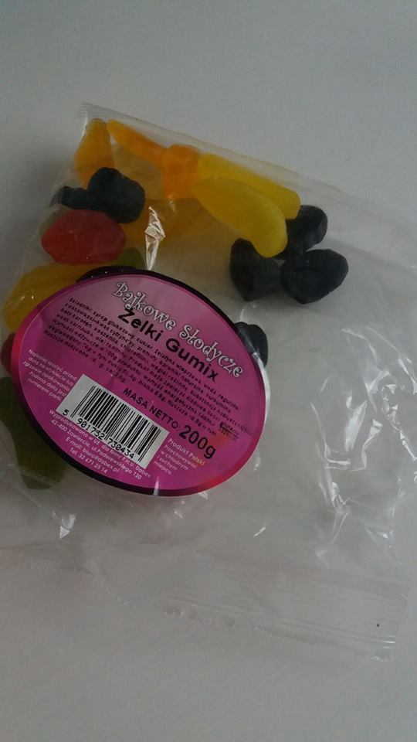
For example, this packaging isn’t good because :
- It is ordinary, uninteresting and not conspicuous.
- It contains no expiration date (Although the sticker reads that the expiry date is located on the package) .
- The package is difficult to open (and it is impossible to close again).
- Product information is written in a very small font so it is hard to be read.

