The product that draws attention and encourages people to buy and use it is "Sweet Secret-shea butter" made by Farmona .
- Two-tone harmonic colours of the container and graphic images are eye-catching for the and bring happy thoughts.
- It arouses curiosity with unusual scent of the gingerbread biscuits.
- The package also has description and composition.
- The brand and name of the product are tempting.
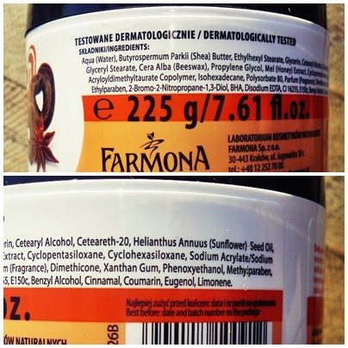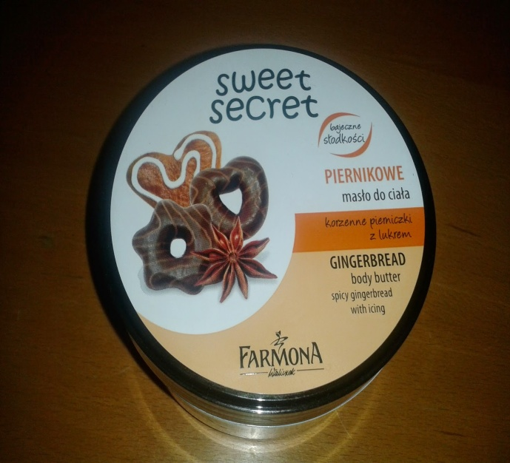
The example of poorly made product is Pierre Rent "Loose Powder".
- The container doesn't make impression of being solidly made.
- The package is minimalistic and doesn't draw much attention.
- There is no list of ingredients.
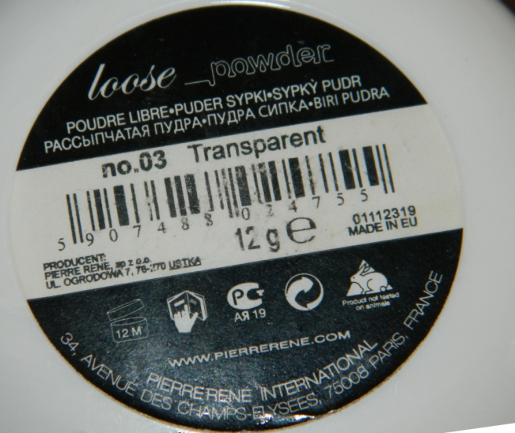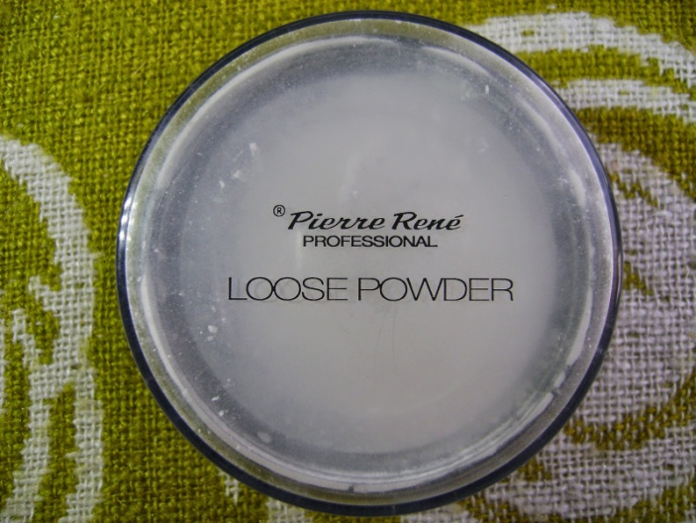

Julia Koszlak 1c1

