Examples of packaging products
Good example:
Features of the package:
- protects the product from heat, moisture, and mechanical impact
- provides freshness, durability
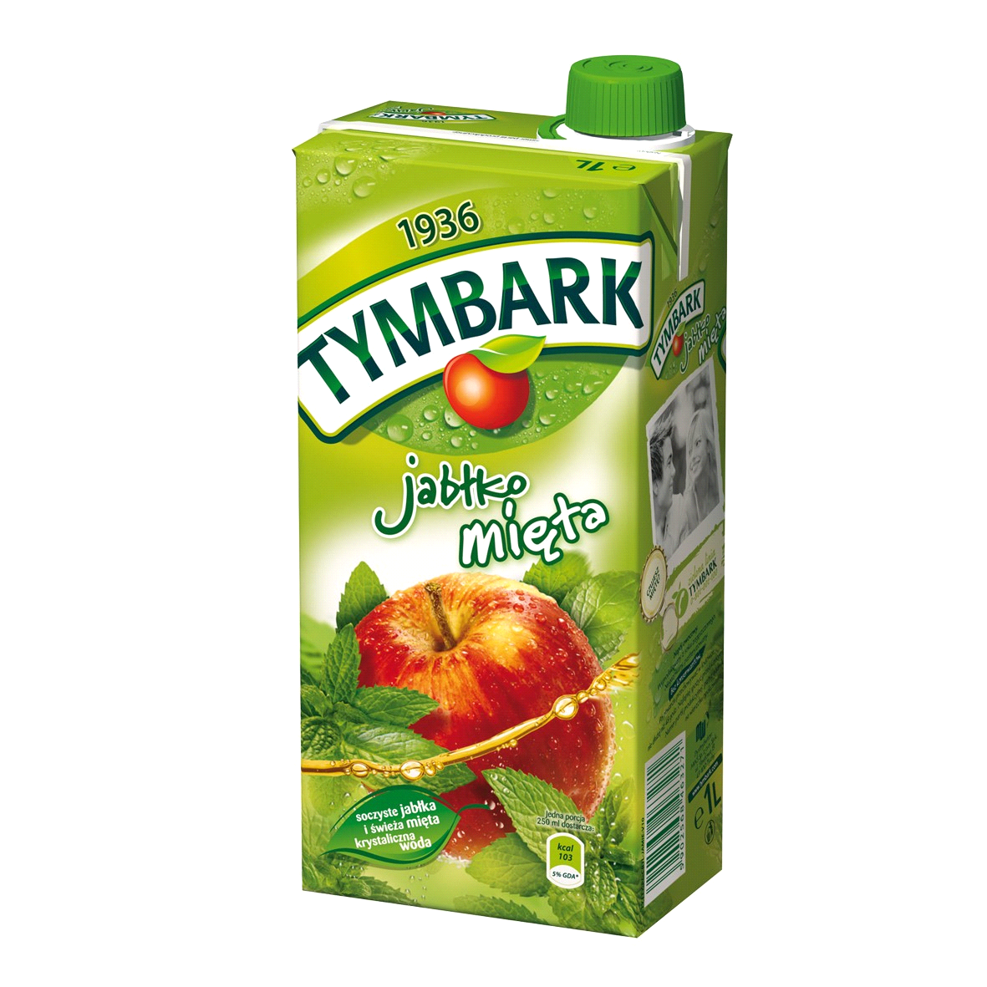
- the buyer is familiar with the type and characteristics of the product, production date, expiry date, price, manufacturer
- encourages people to buy, its packaging is aesthetic
- the packaging is recyclable

Bad example:
The packaging is simple. It is a very thin plastic bottle, which does not provide adequate product protection. The label does not encourage people to buy the product. Plastic is not friendly for environment.

