GOOD AND BAD PACKAGING

Bad packaging

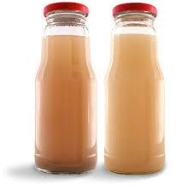
This package object is not good because we cannot find there any information about the product. This packaging does not draw attention. Moreover it does not look attractive for customers.

Good packaging

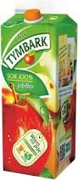
This package is very well done. There we can see every information about this juice. There we read where and how the product was made. Obviously, we also know the expiration date. Finally, the package is colorful and very nice for an eye. I can see there a big apple and the name of the product.

