Advantages and disadvantages of products
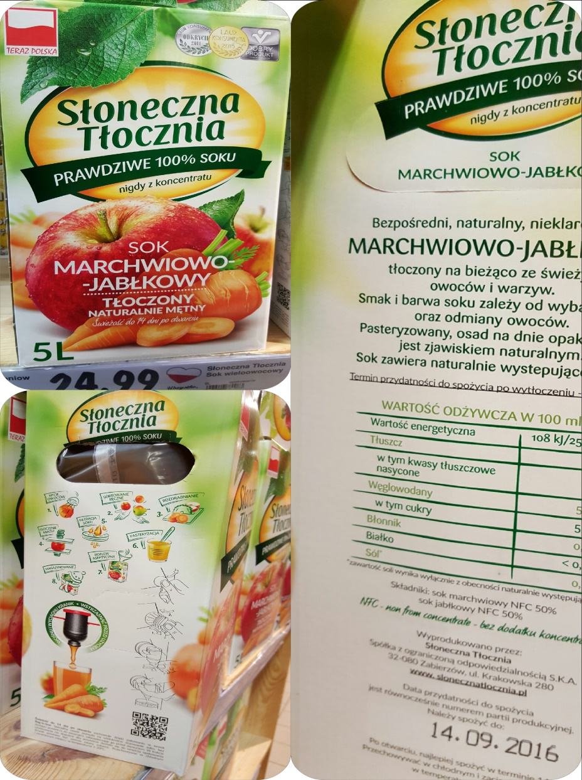
This is example of good product packaging, because:
+it is very colourful and it draws attention,
+it contains instruction how to use it,
+it has got clear description,
+it has got a consumer’s certificates,
+it contains a list of nutritional value,
+product is made in Poland.

It was difficult to find a bad product packaging, because all producers must observe European Union’s requirements, but below there are a few products without complete description.
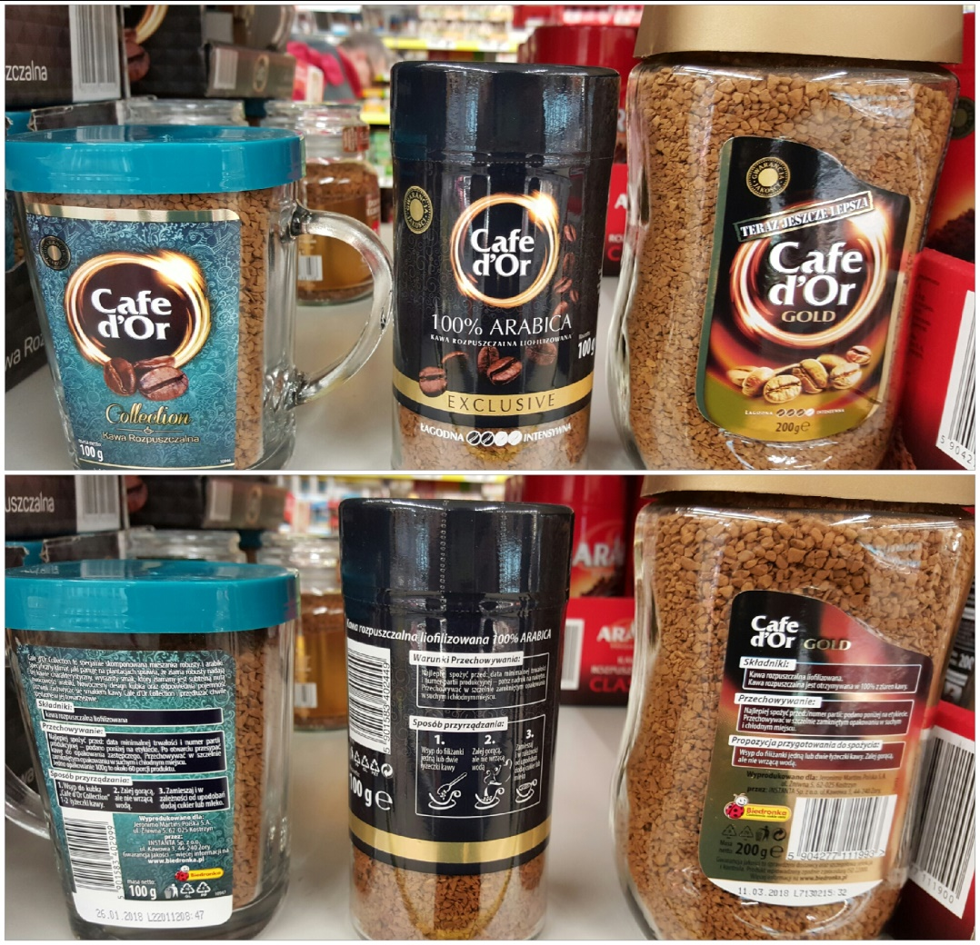

-The coffee jar in the middle hasn’t got ingredients of the product on the label,
-there is a lack of expiration date on the coffee jar in the middle,
-there are huge differences in description between products of the same category,

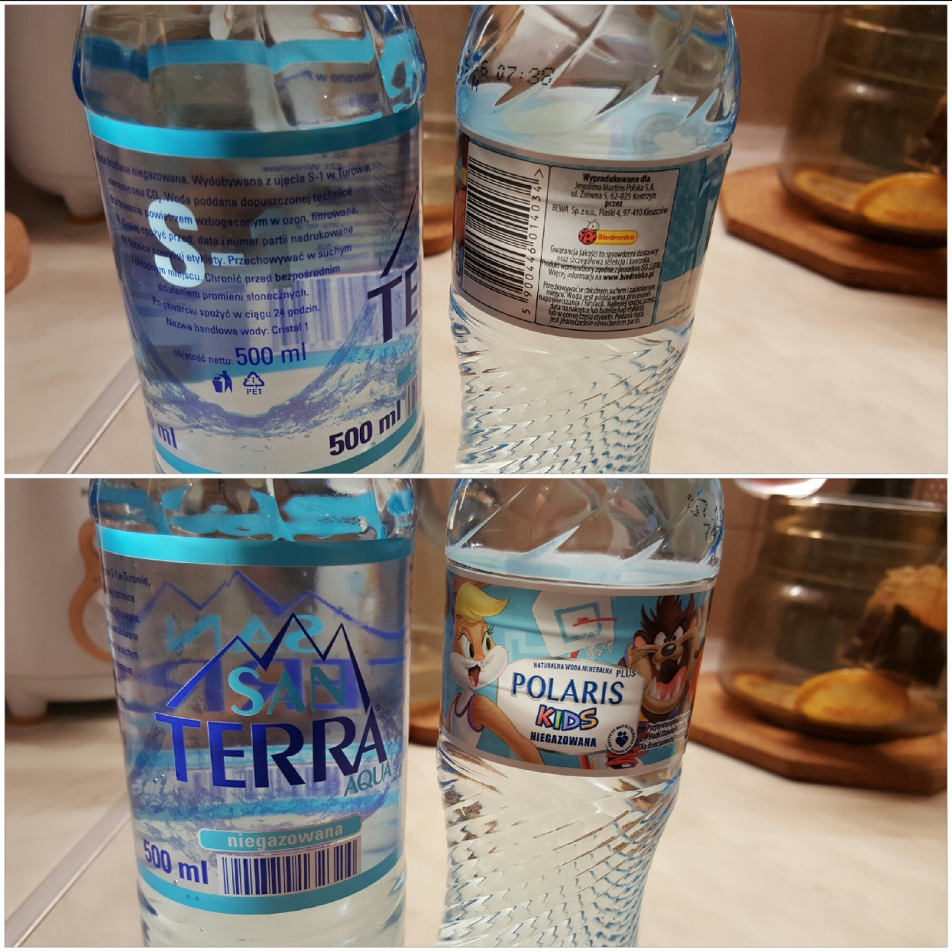
-there is a lack of ingredients of the product on the left,
-the font on the bottle on the left is not clear,
-there is a lack of expiration date.

By Patrycja Godzisz, kl.1c1

