Julia Kassyk kl. II a1

This packaging has a lot of advantages. It is very colourful, it attracts attention and encourages people to buy this product. At the front side there are symbols informing about the characteristics of the product. On the other side all important and specific information appears, e.g. ingredients, nutritional value, sell-by date, information for allergic people and the producer. As a natural and healthy product it also has reference to web side which encourages people to lead healthy lifestyle.
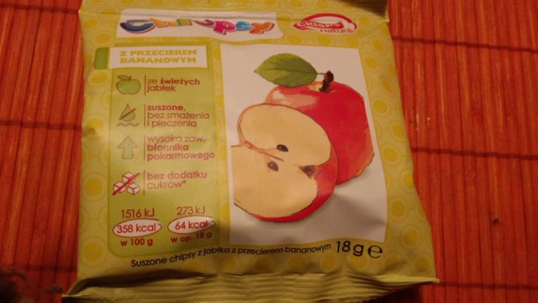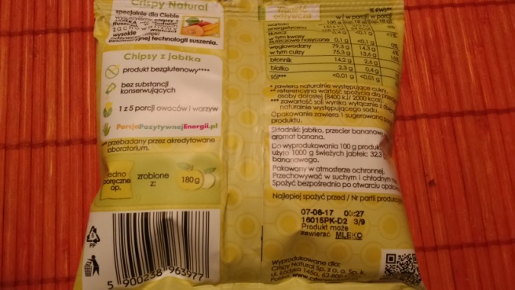
One of the vices of this packaging is that it looks really boring and unattractive. Instant soups are international products often bought by tourists but on this packaging there is no text in English which is international language. There is only information in Polish and Hungarian. This bag also doesn’t provide all needed information, for example about the ingredients. We can see a word “aroma” without any details. Also facts for allergic people aren’t set apart rightly.
