Klaudia Góral

Julia Swat

Erasmus Plus

**Zadanie 2**

**Good package**

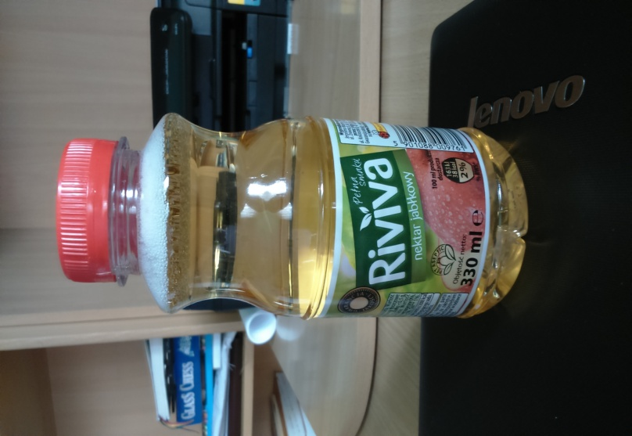

We think this bottle of apple juice is example of well made packaging. It encourages people to buy it. The label is aesthetic and attractive for customers. On the label ingredients are clearly written. The customers can find out about nutritional value of this product. Photo at the front is very nice. The label shows that the product has guarantee of quality. We can also see that this juice was made with using the aseptic method (without preservatives).

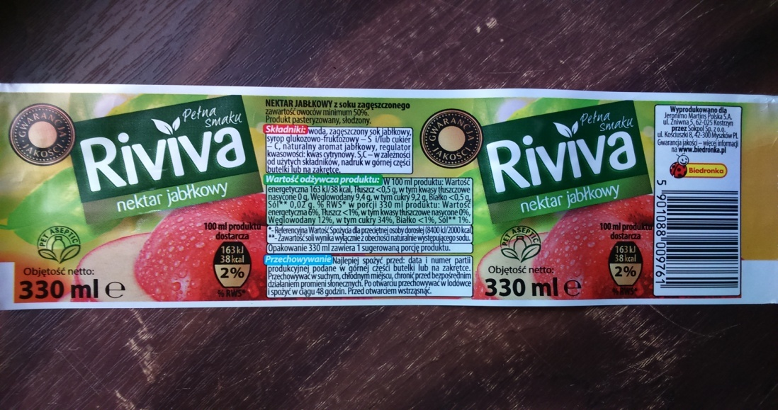

**Bad package**

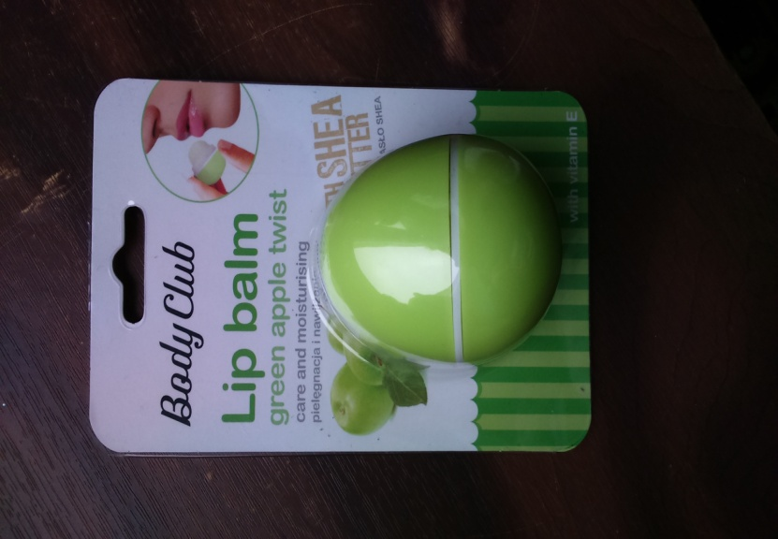

We think this label is bad and it could be better. It isn’t interesting because the front is boring and it is not eye-catching. Information about this lip balm is written in a very small font and it’s hard to read it. The text about the product includes useless information about „magnificence“ of this product. Ingredients are written in Latin.

